UNIVERSIDAD POLITECNICA DE LA ZONA METROPOLITANA DE GUADALAJARA.



ING MECATRONICA.

Enciso Guerrero Benjamin Salvador.

Ingenieria de control.

Carlos Enrique Moran Garabito.

Practica 1: ESTABILIDAD.

8-B.

**Actividad 1**

|  |  |  |  |  |  |
| --- | --- | --- | --- | --- | --- |
| a) |  |  | 1 |  |  |
|  |  |  |  |  |
|  | *s*5 |  *s* 410*s*372*s* 2152*s* 240 | | |
|  |  |

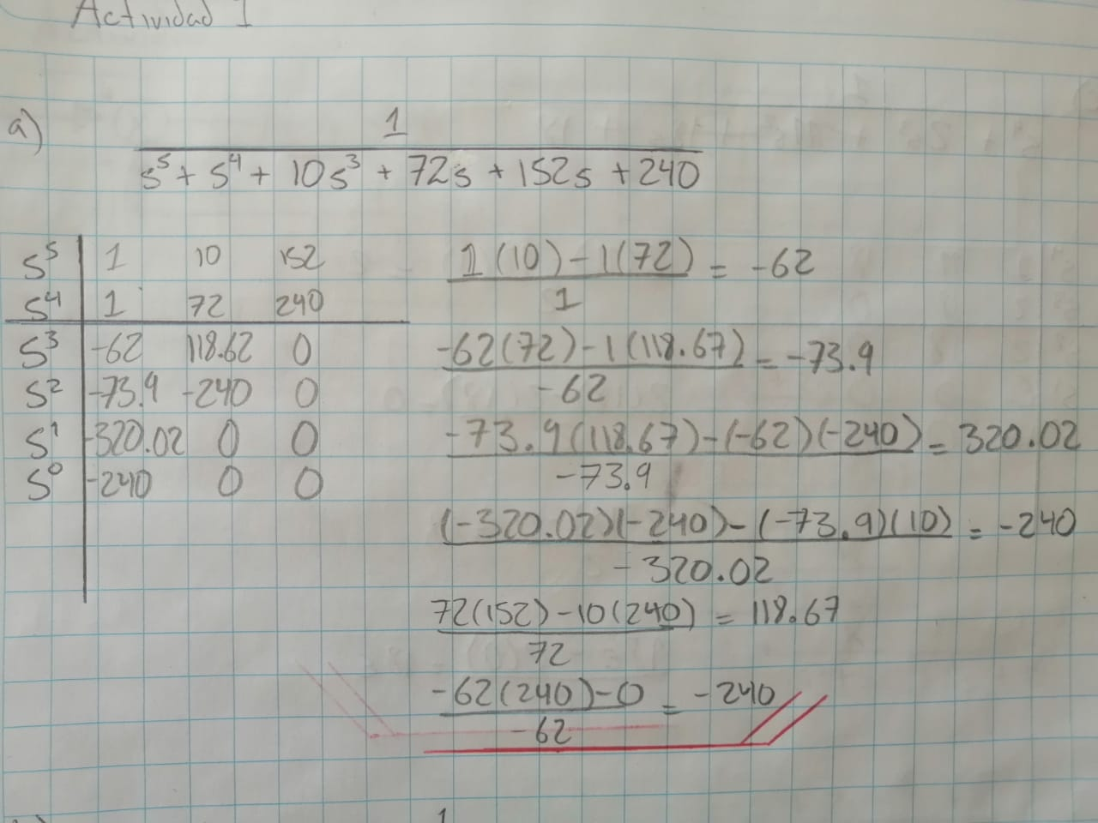

|  |  |  |  |
| --- | --- | --- | --- |
| b) | |  | 1 |
|  |  |
| *s* 4 |  2*s*3  4*s* 2  8*s*  5 | |
|  |  |

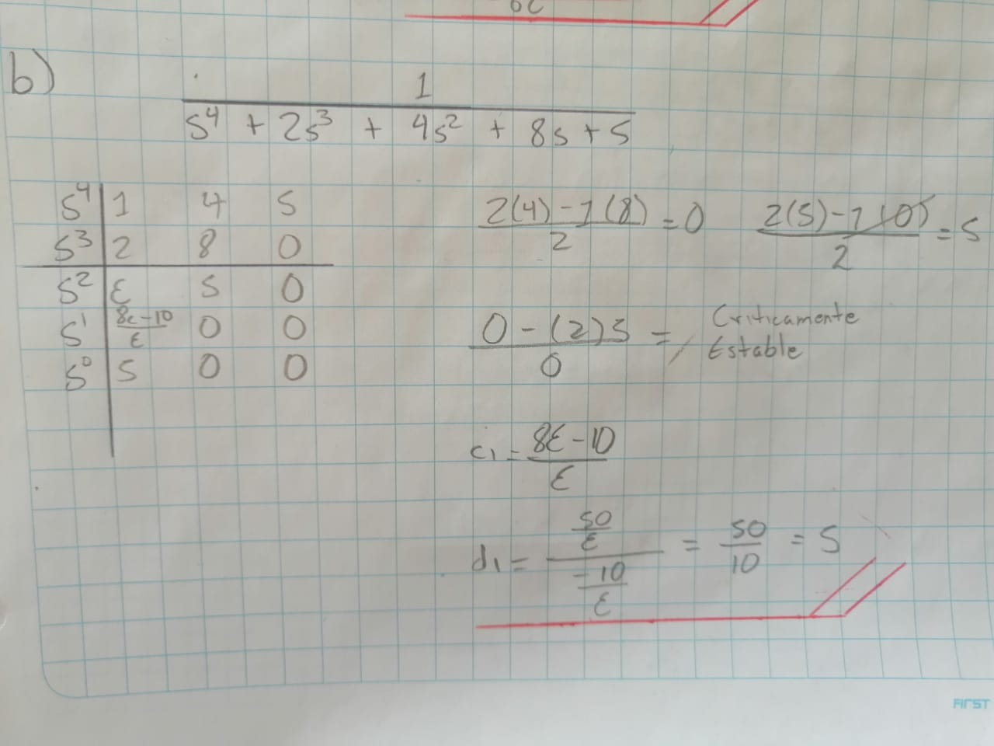

|  |  |  |  |
| --- | --- | --- | --- |
| c) |  |  | 1 |
|  | |  |
|  | |  2*s*3 11*s* 2 18*s* 18 | |

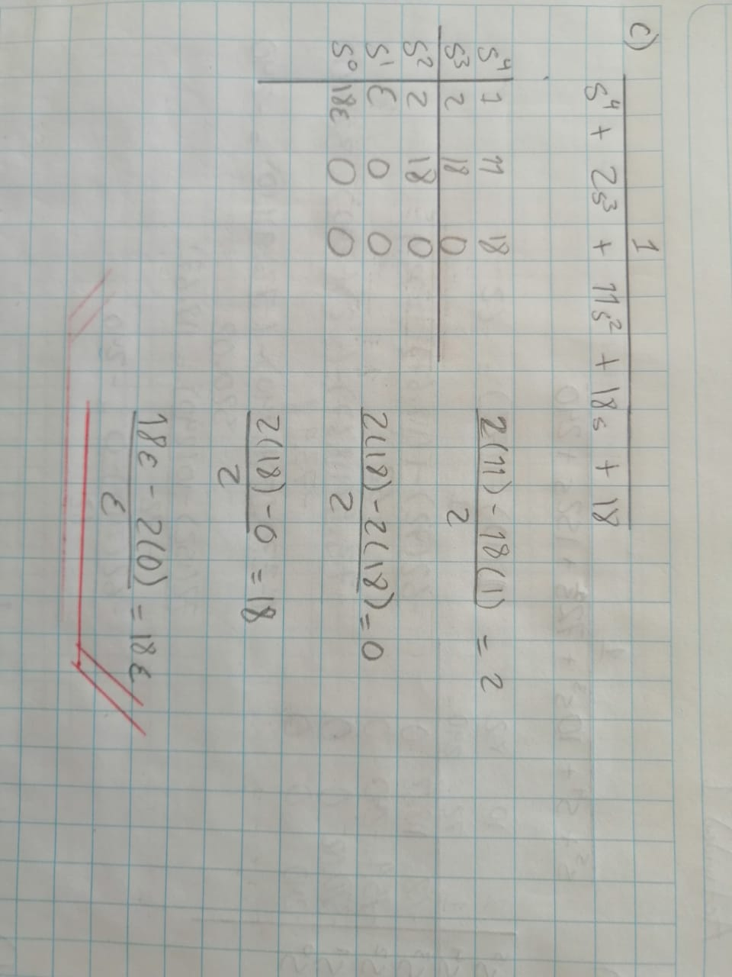

**Actividad 2.** Determinar para qué valores de *K* es estable en los siguientes sistemas:

